KL Wolley
11/25/2018

Week XXX
Recursion
Pg. 168 # 13
- a_{n} = 8a_{n-1} – 16a_{n-2}
  - a_{n} = 0
Substituting 0 for all a_{n} yields:
0 = 8 * 0 – 16 * 0
0 = 0
Because both sides are equal, a_{n} = 0 is a solution of the recurrence relation.

  - a_{n} = 1
Substituting 1 for all a_{n} yields:
1 = 8 * 1 – 16 * 1
1 != -8
Both sides are NOT equal, a_{n} = 1 is NOT a solution.

  - a_{n} = 2^{n}
Substituting 2^{n} for all a_{n} yields:
2^{n} = 8 * 2^{n-1} – 16 * 2^{n-2}
Simplifying the right side of the equation by consolidating exponents:
2^{n} = (8 * * 2 – 16 )2^{n-2}
2^{n} = (16 – 16)2^{n-2}
2^{n} = (0)2^{n-2}
2^{n} != 0
Both sides are NOT equal, a_{n} = 2^{n} is NOT a solution.

  - a_{n} = 4^{n}
Substituting 4^{n} for all a_{n} yields:
4^{n} = 8 * 4^{n-1} – 16 * 4^{n-2}
Simplifying the right side of the equation by consolidating exponents:
4^{n} = (8 * * 4 – 16 )4^{n-2}
4^{n} = (32 – 16)4^{n-2}
4^{n} = (16)4^{n-2}
4^{n} = (4⁴)4^{n-2}
4^{n} = 4^{n-2+4}
4^{n} = 4^{n+2}
Both sides are equal, a_{n} = 4^{n} is a solution.

pg. 510
- Use mathematical induction to verify the formula derived in Example 2 (pg. 503) for the number of moves required to complete the Tower of Hanoi puzzle.
Inductive proof of minimum number of moves required to transfer disks to new peg.
Let n be the number of disks on peg 1.
Let m be the number of moves it takes to transfer the disks.
m = 2^{n} – 1

Base case of n = 0
Moves(0) = n⁰ – 1
= 0
Makes sense that it takes 0 moves to move 0 disks

Inductive Hypothesis (IH): assume that m(n) = 2^{n} – 1 for n >= 0

Show that m(n+1) = 2^{n+1} – 1 is also true
= (2^{n})(2¹) – 1 properties of exponents
= (2^{n})(2) – 1
= 2*2^{n} -1
=2(m(n)) Inductive Hypothesis

- Implement the recursive algorithm for finding gcd. Compare this implementation to your Euclidean algorithm implementation. Try 3 examples. Show me your code and discuss in at least 5 sentences how this compares to the euclidean algorithm. What is the same, what is different? Why should we care? You may add notes or research from internet, but please cite sources.

Recursive gcd | Euclidean
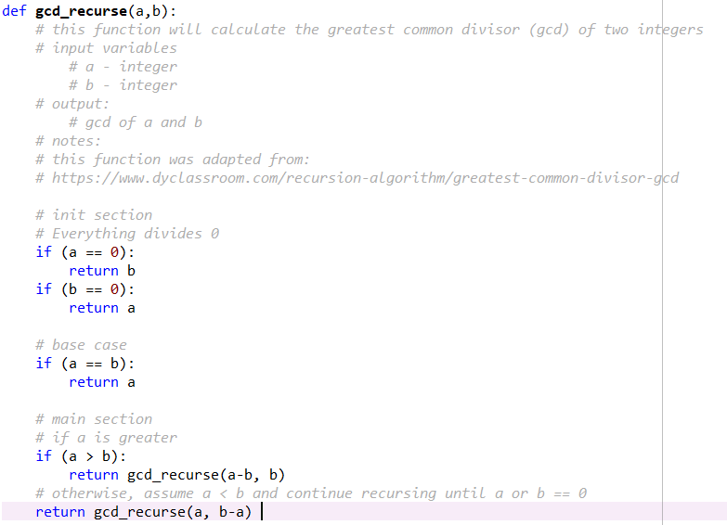 | 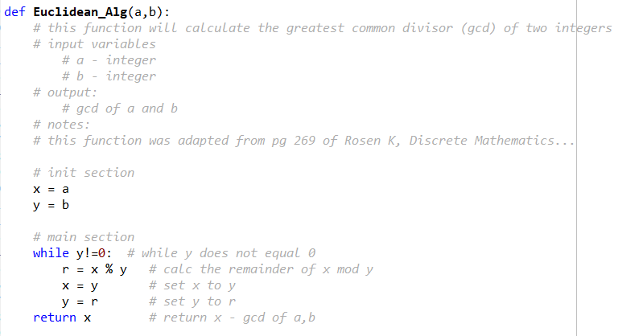

Both cases above implement an initialization section. This section is used to test if either value is == 0 (which, for the recursive method is the termination point). The test for 0 in the Euclidean_Alg is that the while loop will not be entered if y == 0. These codes are very similar, the largest difference is the use of either recursion or a while loop. Recursive methods may be more prone to errors as an inappropriate termination sequence is likely.

- The Fibonacci sequence is related to the famous Golden Ratio Golden Ration Link , tree movie. Implement a program to produce the Fibonacci numbers without recursion. Use f(0) = 0, f(1) =1.

Now, modify your code to calculate the ratio of the nth fib number and the (n-1)th fib number. So you divide things like 13/8, 21/13 etc… and print out the results for the first 20 - 30 terms. What number do you get?

Now change the start values for f(0) and f(1). Pick ANY 2 positive real numbers as your start values. What happens?

Try this with enough new starting numbers to show an interesting pattern and explain your results. Are they surprising?

